Extra Lab Performance:

Graph:

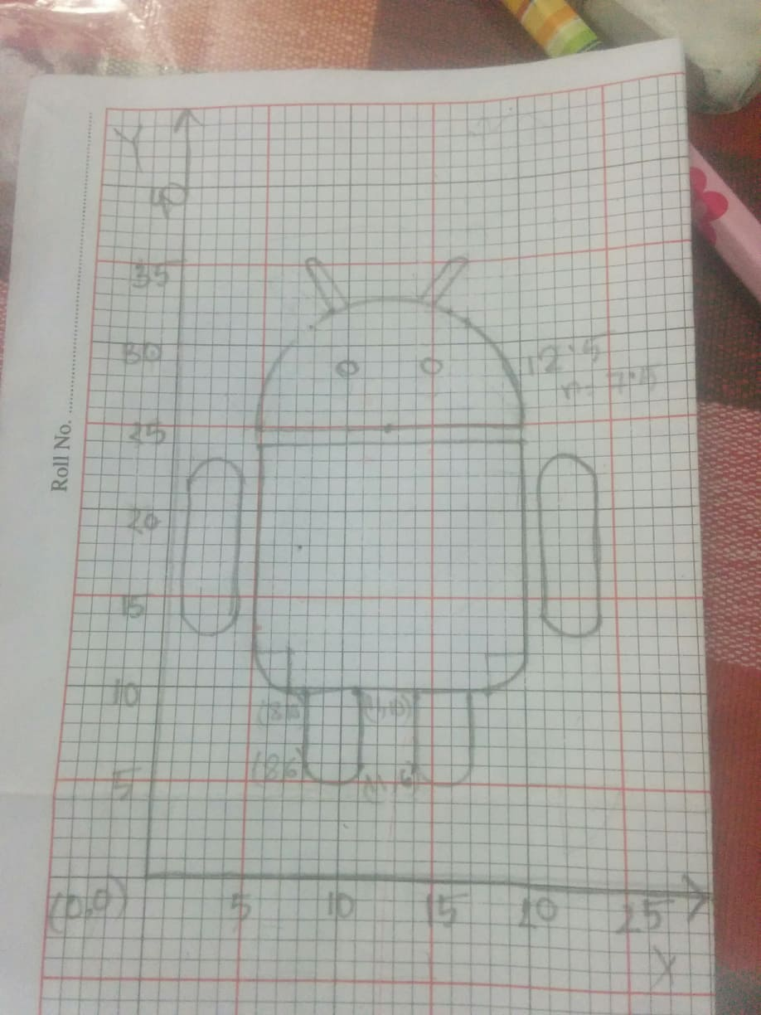

Code:

#include<windows.h>

#include <GL/glut.h>

#include <math.h>

void init(void)

{

glClearColor(0.0, 0.0, 0.0, 0.1); // Set display window color to white

glMatrixMode(GL_PROJECTION); // Set projection parameters

gluOrtho2D(0.0,25.0, 0.0, 40.0);

}

void display()

{

float theta;

int i;

glClear(GL_COLOR_BUFFER_BIT); // Clear display window

glColor3f(1.0, 1.0, 1.0);

glBegin(GL_POLYGON);

glVertex2d(0,0);

glVertex2d(25,0);

glVertex2d(25,40);

glVertex2d(0,40);

glEnd();

//HEAD

glColor3f(0.7f, 1.f, 0.4f);

glBegin(GL_POLYGON);

for(i=1;i<180;i++) // head

{

theta=i*3.142/180;

glVertex2f(12.5+7.5*cos(theta),25+7.5*sin(theta));

}

glEnd();

glColor3f(1.0,1.0,1.0); //eye 1

glBegin(GL_POLYGON);

for(i=0;i<360;i++){

theta=i*3.142/180;

glVertex2f(10+.6*cos(theta),28+.6*sin(theta)); //glVertex2f(250+210*cos(theta),250+210*sin(theta));

}

glEnd();

glColor3f(1.0,1.0,1.0); //eye 2

glBegin(GL_POLYGON);

for(i=0;i<360;i++){

theta=i*3.142/180;

glVertex2f(15+.6*cos(theta),28+.6*sin(theta)); //glVertex2f(250+210*cos(theta),250+210*sin(theta));

}

glEnd();

//LEGG

glColor3f(0.7f, 1.0f, 0.4f);

glBegin(GL_POLYGON);

for(i=180;i<360;i++) // leg1

{

theta=i*3.142/180;

glVertex2f(9.5+1.5*cos(theta),6.2+1.5*sin(theta));

}

glEnd();

glColor3f(0.7f, 1.0f, 0.4f);//leg 1

glBegin(GL_POLYGON);

glVertex2d(8,10);

glVertex2d(8,6);

glVertex2d(11,6);

glVertex2d(11,10);

glEnd();

//LEG2

glColor3f(0.7f, 1.0f, 0.4f);

glBegin(GL_POLYGON);

for(i=180;i<360;i++)

{

theta=i*3.142/180;

glVertex2f(15.5+1.5*cos(theta),6.2+1.5*sin(theta));

}

glEnd();

glColor3f(0.7f, 1.0f, 0.4f);

glBegin(GL_POLYGON);

glVertex2d(14,10);

glVertex2d(17,10);

glVertex2d(17,6);

glVertex2d(14,6);

glEnd();

//hand1

glColor3f(0.7f, 1.0f, 0.4f);

glBegin(GL_POLYGON);

for(i=1;i<180;i++)

{

theta=i*3.142/180;

glVertex2f(2.5+1.5*cos(theta),22+1.5*sin(theta));

}

glEnd();

glColor3f(0.7f, 1.0f, 0.4f);

glBegin(GL_POLYGON);

glVertex2d(1,22);

glVertex2d(4,22);

glVertex2d(4,14);

glVertex2d(1,14);

glEnd();

glColor3f(0.7f, 1.0f, 0.4f);

glBegin(GL_POLYGON);

for(i=180;i<360;i++)

{

theta=i*3.142/180;

glVertex2f(2.5+1.5*cos(theta),14.2+1.5*sin(theta));

}

glEnd();

//hand 2

glColor3f(0.7f, 1.0f, 0.4f);

glBegin(GL_POLYGON);

for(i=1;i<180;i++)

{

theta=i*3.142/180;

glVertex2f(22.5+1.5*cos(theta),22+1.5*sin(theta));

}

glEnd();

glColor3f(0.7f, 1.0f, 0.4f);

glBegin(GL_POLYGON);

glVertex2d(21,22);

glVertex2d(24,22);

glVertex2d(24,14);

glVertex2d(21,14);

glEnd();

glColor3f(0.7f, 1.0f, 0.4f);

glBegin(GL_POLYGON);

for(i=180;i<360;i++)

{

theta=i*3.142/180;

glVertex2f(22.5+1.5*cos(theta),14.2+1.5*sin(theta));

}

glEnd();

//BODY

glColor3f(0.7f, 1.0f, 0.4f);//leg 1

glBegin(GL_POLYGON);

glVertex2d(5,24);

glVertex2d(5,12);

glVertex2d(7,12);

glVertex2d(7,10);

glVertex2d(18,10);

glVertex2d(18,12);

glVertex2d(20,12);

glVertex2d(20,24);

glEnd();

glColor3f(0.7f, 1.0f, 0.4f);

glBegin(GL_POLYGON);

for(i=180;i<360;i++)

{

theta=i*3.142/180;

glVertex2f(7+2*cos(theta),12+2*sin(theta));

}

glEnd();

glColor3f(0.7f, 1.0f, 0.4f);

glBegin(GL_POLYGON);

for(i=180;i<360;i++)

{

theta=i*3.142/180;

glVertex2f(18+2*cos(theta),12+2*sin(theta));

}

glEnd();

//SHING

glColor3f(0.7f, 1.0f, 0.4f);

glBegin(GL_POLYGON);

for(i=0;i<180;i++)

{

theta=i*3.142/180;

glVertex2f(15.75+.25*cos(theta),35+.25*sin(theta));

}

glEnd();

glColor3f(0.7f, 1.0f, 0.4f);//SHING 2

glBegin(GL_POLYGON);

glVertex2d(15,32);

glVertex2d(14.5,32);

glVertex2d(15.5,35);

glVertex2d(16,35);

glEnd();

glColor3f(0.7f, 1.0f, 0.4f);

glBegin(GL_POLYGON);

for(i=0;i<180;i++)

{

theta=i*3.142/180;

glVertex2f(8.75+.25*cos(theta),35+.25*sin(theta));

}

glEnd();

glColor3f(0.7f, 1.0f, 0.4f);//SHING 1

glBegin(GL_POLYGON);

glVertex2d(10,31);

glVertex2d(9.5,31);

glVertex2d(8.5,35);

glVertex2d(9,35);

glEnd();

glFlush();

}

int main(int argc, char* argv[])

{

glutInit(&argc, argv);

glutInitDisplayMode(GLUT_SINGLE|GLUT_RGB);

glutInitWindowPosition(100, 100);

glutInitWindowSize(350, 350);

glutCreateWindow("Iffat Firozy Rimi 163-15-8432");

init();

glutDisplayFunc(display);

glutMainLoop();

return 0;

}

Output:



